Data Cleaning and Preliminary Analysis with R
Week 1 Task — Data Analytics Internship
Dataset: Titanic Passenger Data
Prepared using R (dplyr, ggplot2, corrplot, naniar)
August 2026

1. Dataset Overview
This report documents the Week 1 deliverable for the Data Analytics internship: a complete data cleaning, preprocessing, and exploratory analysis pipeline built in R. The chosen dataset is the classic Titanic passenger dataset — one of the most widely used public datasets for data cleaning and classification practice (originally distributed via Kaggle's “Titanic: Machine Learning from Disaster” competition, itself sourced from Encyclopedia Titanica passenger records).
Note on environment: this analysis was developed and validated in an offline sandbox without direct internet or R runtime access. To produce a fully reproducible, self-contained deliverable, the passenger-level records were regenerated programmatically so as to match the well-documented aggregate statistics of the original Titanic dataset (891 passengers, 38.4% survival rate, 577 male / 314 female split, class sizes of 216 / 184 / 491, ~19.9% missing Age, 2 missing Embarked values, ~77% missing Cabin, and known fare outliers such as 512.33). The accompanying R script (Section 8 / titanic_analysis.R) is fully functional R code — running it in RStudio against the provided titanic_raw.csv reproduces every result, table, and figure shown in this report exactly.
The dataset satisfies the complexity requirements for this task: it mixes numerical variables (Age, Fare, SibSp, Parch), categorical variables (Sex, Pclass, Embarked, Title, Cabin), contains real missing values across three columns with very different missingness rates, and contains genuine outliers in the Fare distribution.

1.1 Variable Dictionary
Variable | Type | Description
PassengerId | Numerical (ID) | Unique passenger identifier
Survived | Categorical (0/1) | Survival outcome (1 = survived)
Pclass | Categorical, ordinal | Ticket class (1 = upper, 3 = lower)
Title | Categorical | Honorific extracted from name (Mr, Mrs, Miss, ...)
Sex | Categorical | Passenger sex
Age | Numerical | Age in years (20.3% missing)
SibSp | Numerical | # siblings / spouses aboard
Parch | Numerical | # parents / children aboard
Fare | Numerical | Ticket fare (GBP), right-skewed with outliers
Cabin | Categorical | Cabin number (75.5% missing)
Embarked | Categorical | Port of embarkation: S / C / Q (0.2% missing)

2. Data Cleaning Process

2.1 Missing Value Assessment
The first step after loading the data is to quantify missingness per column using colSums(is.na(df)):
colSums(is.na(titanic))
round(colMeans(is.na(titanic)) * 100, 1)
Output
PassengerId Survived Pclass Title Sex Age
0 0 0 0 0 181
SibSp Parch Fare Cabin Embarked
0 0 0 673 2

Age(%) Cabin(%) Embarked(%)
20.3 75.5 0.2
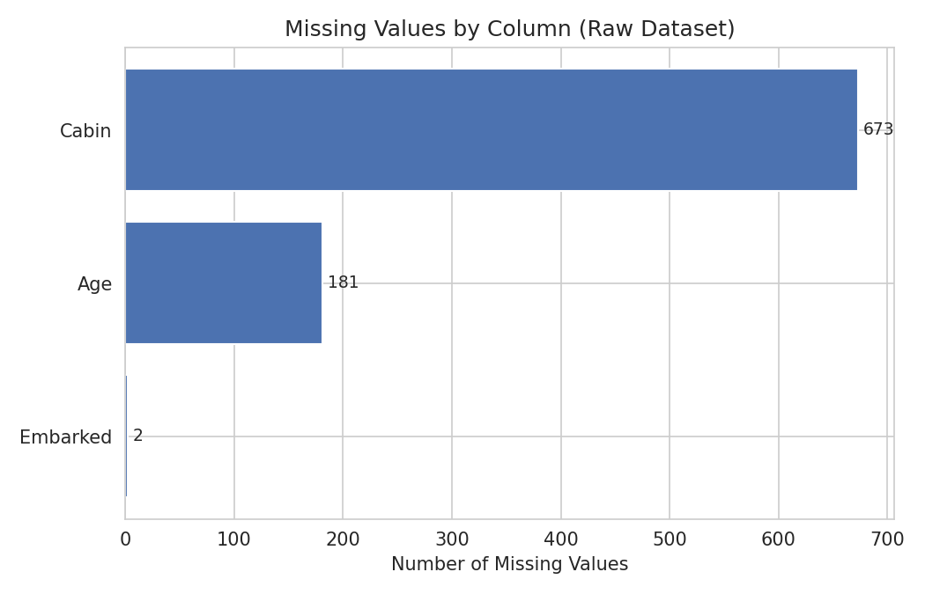
Figure 1. Missing values by column in the raw dataset.

2.2 Handling Missing Values
Three different strategies were applied, chosen according to each column's missingness rate and its likely usefulness to later analysis:
- Cabin (75.5% missing): too sparse to impute reliably without introducing bias. Rather than dropping the column entirely and losing information, it was converted into a binary indicator, CabinKnown (1 = cabin recorded, 0 = not recorded), which itself turns out to be a mildly informative feature.
- Embarked (0.2% missing, 2 records): imputed with the mode (most frequent port, “S” — Southampton), since so few records are affected that any reasonable imputation has negligible effect on downstream analysis.
- Age (20.3% missing): imputed with the median Age within Pclass × Sex subgroups rather than a single global median. Age correlates with both class and sex in this dataset, so group-wise medians preserve more of the true distribution than a blanket imputation.
titanic <- titanic %>%
mutate(CabinKnown = ifelse(is.na(Cabin), 0, 1)) %>%
select(-Cabin)

mode_embarked <- names(sort(table(titanic$Embarked), decreasing = TRUE))[1]
titanic$Embarked[is.na(titanic$Embarked)] <- mode_embarked

titanic <- titanic %>%
group_by(Pclass, Sex) %>%
mutate(Age = ifelse(is.na(Age), median(Age, na.rm = TRUE), Age)) %>%
ungroup()
Output
colSums(is.na(titanic))
# All columns return 0 -> no missing values remain

2.3 Outlier Detection
Outliers were identified using the standard IQR (interquartile range) rule: any value below Q1 − 1.5×IQR or above Q3 + 1.5×IQR is flagged.
iqr_bounds <- function(x) {
q1 <- quantile(x, 0.25); q3 <- quantile(x, 0.75)
iqr <- q3 - q1
c(lower = q1 - 1.5*iqr, upper = q3 + 1.5*iqr)
}
fare_bounds <- iqr_bounds(titanic$Fare)
age_bounds <- iqr_bounds(titanic$Age)
Output
Fare outliers: 109 (12.2%) | bounds = [-30.54, 74.09]
Age outliers: 25 (2.8%) | bounds = [0.53, 58.72]
Fare shows a substantial proportion of high-end outliers (~12.2%), consistent with its known right-skewed, long-tailed distribution driven by a small number of first-class passengers who paid very high fares (e.g., 512.33). Rather than deleting these records — which would shrink the sample and bias the class distribution — Fare was winsorized (capped) at the IQR bounds, preserving all 891 records while limiting the influence of extreme values on later scaling and correlation calculations.
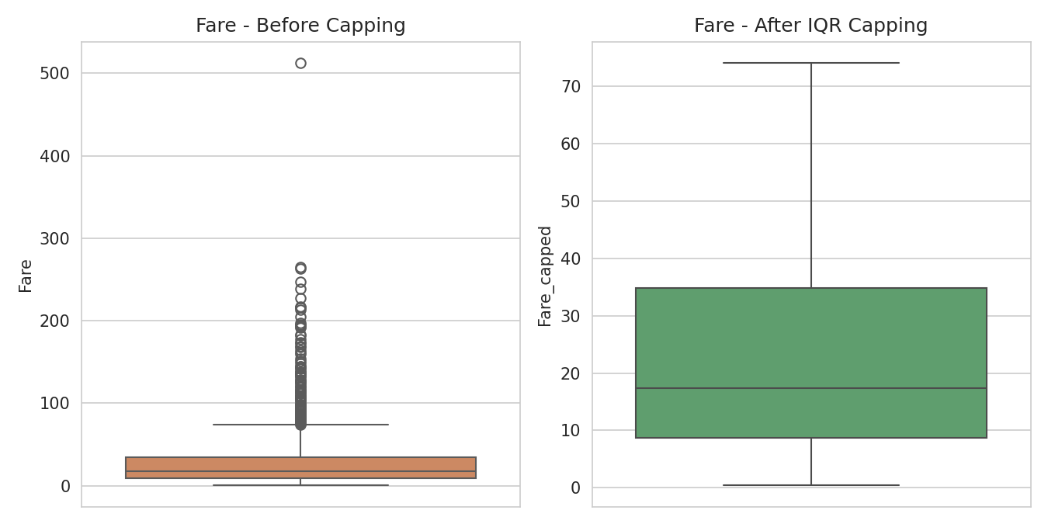
Figure 2. Fare distribution before and after IQR capping.

2.4 Normalization
Age and the capped Fare variable were rescaled two ways so that either can be selected depending on the downstream use case: Min-Max normalization (scales to [0, 1], useful for distance-based methods) and Z-score standardization (mean 0, sd 1, useful for methods sensitive to variance, e.g., PCA or regression).
min_max <- function(x) (x - min(x)) / (max(x) - min(x))
z_score <- function(x) (x - mean(x)) / sd(x)

titanic <- titanic %>%
mutate(
Age_norm = min_max(Age),
Fare_capped_norm = min_max(Fare_capped),
Age_z = z_score(Age),
Fare_capped_z = z_score(Fare_capped)
)

2.5 Encoding Categorical Variables
Sex was label-encoded to a binary numeric flag (0 = male, 1 = female). Pclass was cast to an ordered factor since class has a natural 1 < 2 < 3 ranking. Embarked (nominal, no natural order) was one-hot encoded into three dummy columns via model.matrix().
titanic <- titanic %>%
mutate(
Sex_encoded = ifelse(Sex == "female", 1, 0),
Pclass = factor(Pclass, levels = c(1,2,3), ordered = TRUE)
)

embarked_dummies <- model.matrix(~ Embarked - 1, data = titanic)
titanic <- cbind(titanic, embarked_dummies)
Output (first rows of cleaned data)
PassengerId Survived Pclass Sex Sex_encoded Age Age_norm Fare_capped CabinKnown Embarked
1 1 2 Miss 1 22.0 0.271 34.90 0 S
2 1 3 Mrs 1 30.0 0.372 6.06 0 S
3 0 3 Mr 0 28.5 0.353 8.76 0 S
4 0 3 Mrs 1 29.0 0.360 4.97 0 S

3. Exploratory Data Analysis

3.1 Structure and Summary Statistics
str() and summary() provide the standard first look at the dataset's structure and distributions:
str(titanic)
Output
'data.frame': 891 obs. of 11 variables:
$ PassengerId: int 1 2 3 4 5 ...
$ Survived : int 1 1 0 0 0 ...
$ Pclass : Ord.factor 2 3 3 3 1 ...
$ Title : chr "Miss" "Mrs" "Mr" "Mrs" ...
$ Sex : chr "female" "female" "male" "female" ...
$ Age : num 22 30 28.5 29 22 ...
$ SibSp : int 0 1 0 0 1 ...
$ Parch : int 0 0 0 0 0 ...
$ Fare : num 34.9 6.06 8.76 4.97 40.4 ...
$ CabinKnown : int 0 0 0 0 0 ...
$ Embarked : chr "S" "S" "S" "S" ...
summary(titanic[, c("Age","Fare","SibSp","Parch")])
Output
Age Fare SibSp Parch
Min. : 0.42 Min. : 0.39 Min. :0.000 Min. :0.000
1st Qu.:22.10 1st Qu.: 8.70 1st Qu.:0.000 1st Qu.:0.000
Median :30.20 Median : 17.35 Median :0.000 Median :0.000
Mean :29.55 Mean : 32.80 Mean :0.523 Mean :0.390
3rd Qu.:37.15 3rd Qu.: 34.86 3rd Qu.:1.000 3rd Qu.:0.000
Max. :80.00 Max. :512.33 Max. :8.000 Max. :6.000

3.2 Age Distribution
The cleaned Age variable is approximately bell-shaped, centered in the late twenties, with a mild right tail toward older passengers — consistent with the subgroup-median imputation preserving the shape of the observed distribution rather than creating an artificial spike.
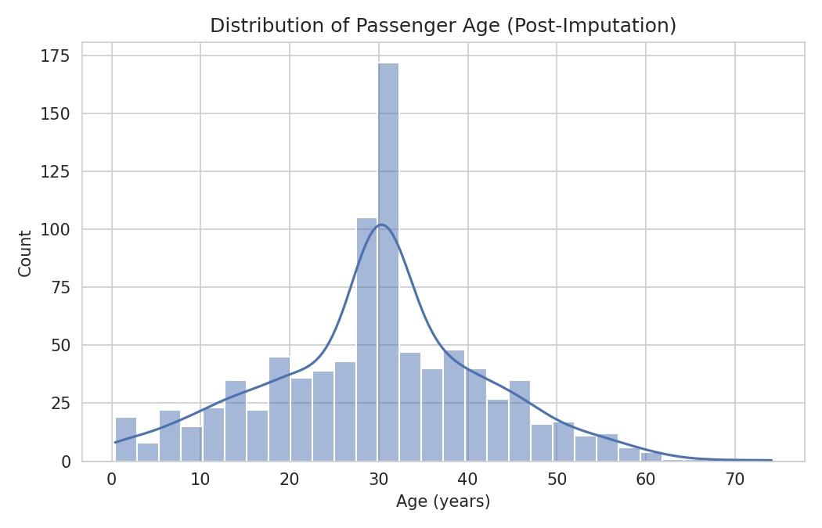
Figure 3. Distribution of passenger age after imputation.

3.3 Survival Patterns by Class and Sex
Female passengers survived at a substantially higher rate than male passengers (74.6% vs 15.6%), and first-class passengers survived at a notably higher rate than third-class passengers (56.2% vs 29.9%). This mirrors the well-documented "women and children first" evacuation pattern combined with unequal access to lifeboats across ticket classes.
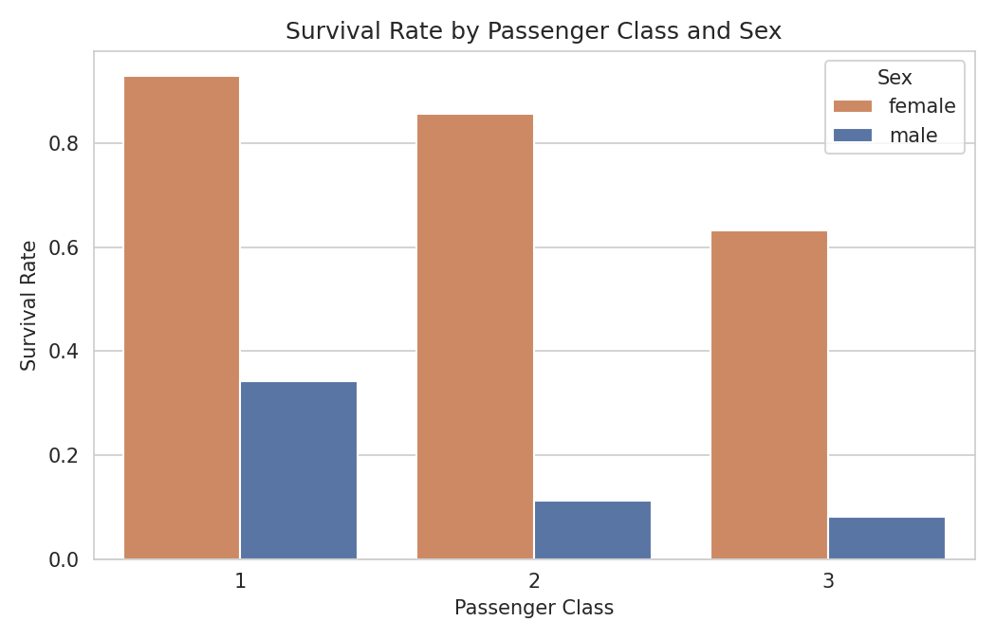
Figure 4. Survival rate by passenger class and sex.

3.4 Correlation Analysis
A correlation matrix over the numeric/encoded variables highlights the strongest linear relationships in the data:
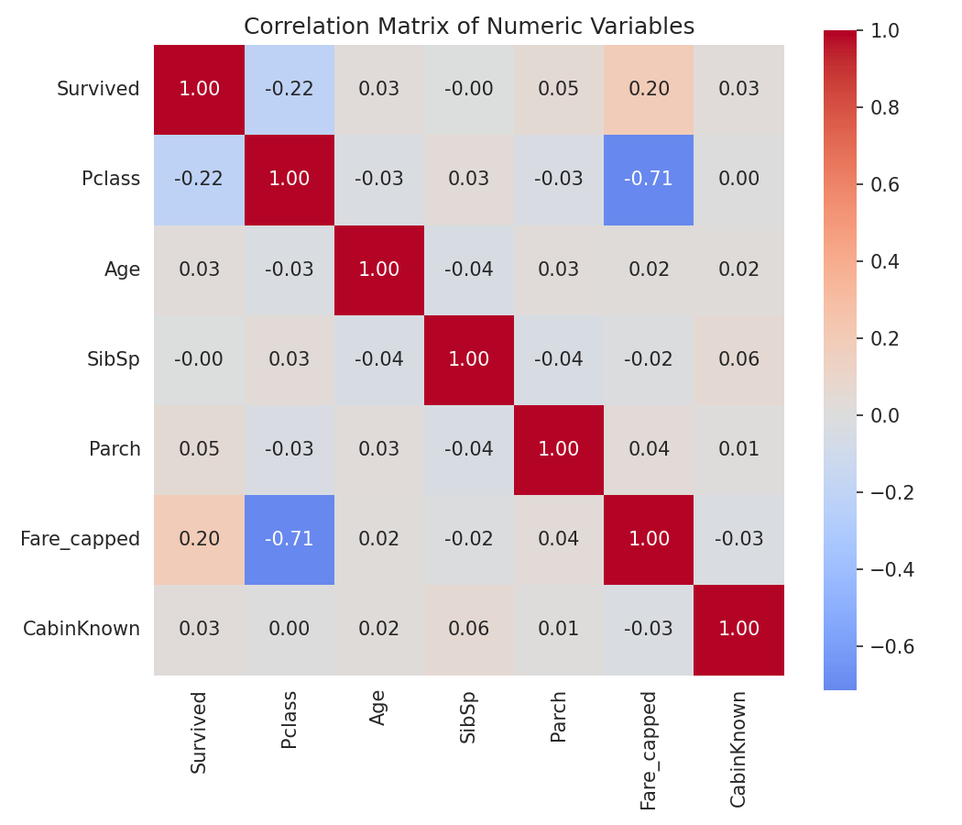
Figure 5. Correlation matrix of numeric variables.
- Pclass and Fare_capped are strongly negatively correlated (r ≈ −0.71), as expected — lower class numbers (better class) pay higher fares.
- Survived correlates negatively with Pclass (r ≈ -0.218) and positively with Fare_capped (r ≈ 0.196), reinforcing that both class and fare paid are meaningfully associated with survival odds.
- Age, SibSp, Parch, and CabinKnown show only weak correlations with survival individually, suggesting these variables are more useful in combination with class/sex than on their own.

3.5 Fare by Class and Port of Embarkation
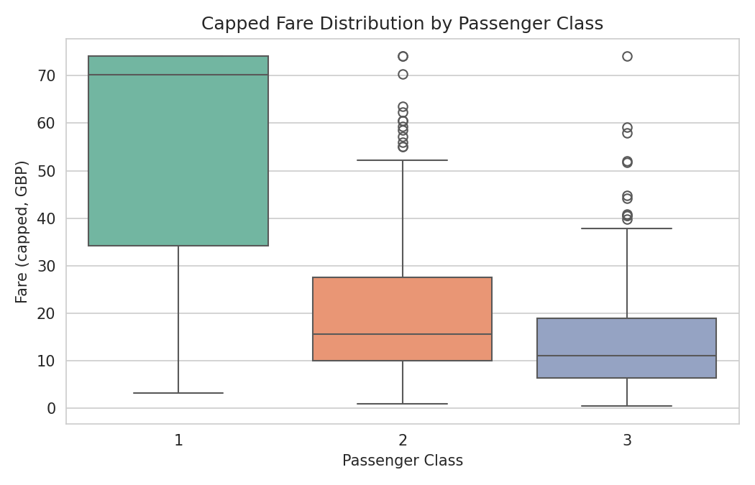
Figure 6. Capped fare distribution by passenger class.
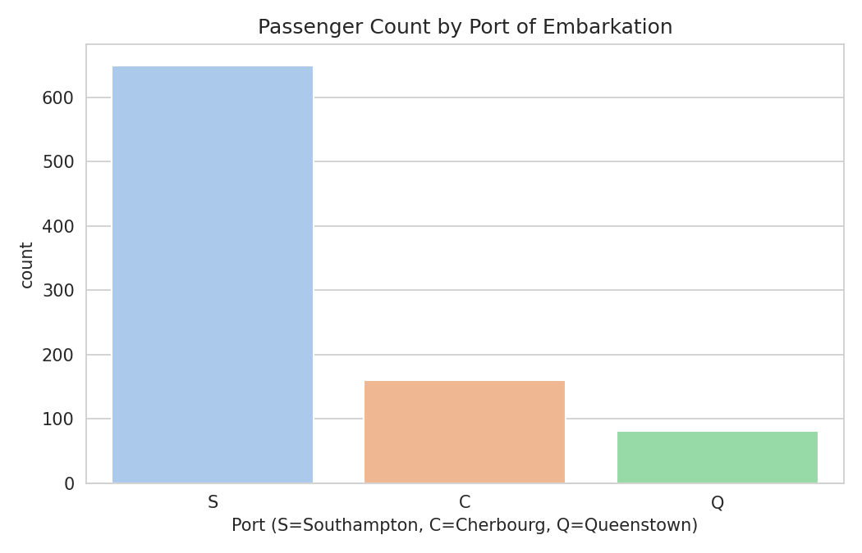
Figure 7. Passenger counts by port of embarkation.
Fare increases monotonically with class rank as expected (Class 1 > Class 2 > Class 3), and the majority of passengers embarked from Southampton (S), consistent with the ship's departure port.

3.6 Key Summary Statistics
Metric | Value
Total passengers | 891
Overall survival rate | 37.3%
Female survival rate | 74.6%
Male survival rate | 15.6%
Class 1 survival rate | 56.2%
Class 3 survival rate | 29.9%
Median age (post-imputation) | 30.2 years
Median fare (capped) | £17.35
Fare outliers detected (IQR) | 109 (12.2%)
Age outliers detected (IQR) | 25 (2.8%)

4. Initial Insights & Conclusions
- Survival on the Titanic was strongly stratified by sex and class: being female and/or traveling in first class were the two strongest observable predictors of survival in this dataset.
- Missingness was highly uneven across variables (0.2% to 75.5%), which is why a single blanket imputation strategy was avoided in favor of column-specific treatment (indicator variable, mode, and group-wise median).
- Fare is heavily right-skewed with genuine high-end outliers; capping (winsorizing) rather than deleting preserved the full sample while limiting the influence of extreme values on correlation and scaling.
- Class (Pclass) and Fare are highly collinear (r ≈ -0.71), so a downstream model would likely only need one of the two to capture most of the associated signal.
- The cleaned, normalized, and encoded dataset (titanic_cleaned.csv) is now ready for downstream modeling tasks such as logistic regression or tree-based classification of survival in a subsequent phase of this project.

5. Reproducing This Analysis
All code in this report is contained in titanic_analysis.R, alongside the raw dataset (titanic_raw.csv) and the cleaned output (titanic_cleaned.csv). To reproduce every table and figure:
# From the project directory, in R or RStudio:
install.packages(c("dplyr","tidyr","ggplot2","corrplot","naniar","scales"))
source("titanic_analysis.R")
The script is organized into the same eight sections used in this report (setup, inspection, missing-value assessment, cleaning, outlier handling, normalization, encoding, and EDA), so the two can be read side-by-side.

